CS 520 OS Project | CWID 10430147 | Divyendra Patil | Username: dpatil3  
Date: 11/05/2017

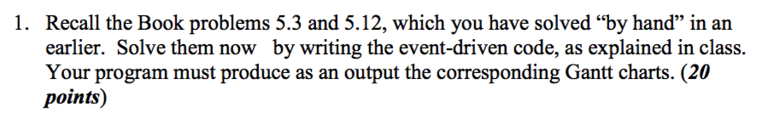

Solution:

i] Turnaround time = Completion time – Arrival time

|  |  |  |
| --- | --- | --- |
| Process | Arrival Time | Burst Time |
| P1 | 0.0 | 8 |
| P2 | 0.4 | 4 |
| P3 | 1.0 | 1 |

a] Average turn-around time for First Come First Serve:

Grant-chart:

|  |  |  |
| --- | --- | --- |
| P1 | P2 | P3 |

1. 8.0 12.0 13.0

|  |  |  |  |  |
| --- | --- | --- | --- | --- |
| Process | Arrival Time | Burst Time | Completion Time | Turn Around Time |
| P1 | 0.0 | 8 | 8.0 | 8.0 |
| P2 | 0.4 | 4 | 12.0 | 11.6 |
| P3 | 1.0 | 1 | 13.0 | 12.0 |

Average turnaround time = (8.0+11.6+12.0)/3 = 10.53

b] Average turn-around time for SJF non-preemptive:

Since P1 arrived at 0.0 time interval and considering non-preemptive version of SJF P3 will execute before P2 but after P1.

Grant-chart:

|  |  |  |
| --- | --- | --- |
| P1 | P2 | P3 |

1. 8.0 9.0 13.0

|  |  |  |  |  |
| --- | --- | --- | --- | --- |
| Process | Arrival Time | Burst Time | Completion Time | Turn Around Time |
| P1 | 0.0 | 8 | 8.0 | 8.0 |
| P3 | 1.0 | 1 | 9.0 | 8.0 |
| P2 | 0.4 | 4 | 13.0 | 12.6 |

Average turnaround time = (8.0+8.0+12.6)/3 = 9.53

c] Average turn-around time for SJF preemptive:

|  |  |  |  |
| --- | --- | --- | --- |
| Idle | P3 | P3 | P1 |

0.0 1.0 2.0 6.0 14

|  |  |  |  |  |
| --- | --- | --- | --- | --- |
| Process | Arrival Time | Burst Time | Completion Time | Turn Around Time |
| P1 | 0.0 | 8 | 14.0 | 14.0 |
| P3 | 1.0 | 1 | 2.0 | 1.0 |
| P2 | 0.4 | 4 | 6.0 | 5.6 |

Average turnaround time = (14.0 + 1.0 + 5.6) / 3 = 6.87

ii]

|  |  |  |
| --- | --- | --- |
| Process | Burst Time | Priority |
| P1 | 10 | 3 |
| P2 | 1 | 1 |
| P3 | 2 | 3 |
| P4 | 1 | 4 |
| P5 | 5 | 2 |

**First Come First Serve**:

|  |  |  |  |  |
| --- | --- | --- | --- | --- |
| P1 | P2 | P3 | P4 | P5 |

0 10 11 13 14 19

**Shortest Job First**:

|  |  |  |  |  |
| --- | --- | --- | --- | --- |
| P2 | P4 | P3 | P5 | P1 |

0 1 2 4 9 19

**Non-preemptive priority**:

|  |  |  |  |  |
| --- | --- | --- | --- | --- |
| P2 | P5 | P3 | P1 | P4 |

0 1 6 8 18 19

**Round robin (quanta =1)**:

|  |  |  |  |  |  |  |  |  |  |  |  |  |  |  |
| --- | --- | --- | --- | --- | --- | --- | --- | --- | --- | --- | --- | --- | --- | --- |
| P1 | P2 | P3 | P4 | P5 | P1 | P3 | P5 | P1 | P5 | P1 | P5 | P1 | P5 | P1 |

0 1 2 3 4 5 6 7 8 9 10 11 12 13 14 19

b] **Turnaround time = Completion time – Arrival time**

|  |  |  |  |  |
| --- | --- | --- | --- | --- |
|  | FCFS | SJF | Priority | RR |
| P1 | 10 | 19 | 18 | 19 |
| P2 | 11 | 1 | 1 | 2 |
| P3 | 13 | 4 | 8 | 7 |
| P4 | 14 | 2 | 19 | 4 |
| P5 | 19 | 9 | 6 | 14 |

c] **Waiting time = Turnaround time – burst time**

|  |  |  |  |  |
| --- | --- | --- | --- | --- |
|  | FCFS | SJF | Priority | RR |
| P1 | 0 | 9 | 8 | 9 |
| P2 | 10 | 0 | 0 | 1 |
| P3 | 11 | 2 | 6 | 5 |
| P4 | 13 | 1 | 18 | 3 |
| P5 | 14 | 4 | 1 | 9 |

d]

FCFS: Average waiting time = (0+10+11+13+14)/5 = 9.6

SJF: Average waiting time = (9+0+2+1+4)/5 = 3.2

Priority: Average waiting time = (8+0+6+18+1)/5 = 6.6

RR: Average waiting time = (9+1+5+3+9)/5 = 5.4

**ScreenShots for Output of FCFS, SJF, Priority, Round Robin**

**(All Logs are attached to the project)**

**Question 5.3:**

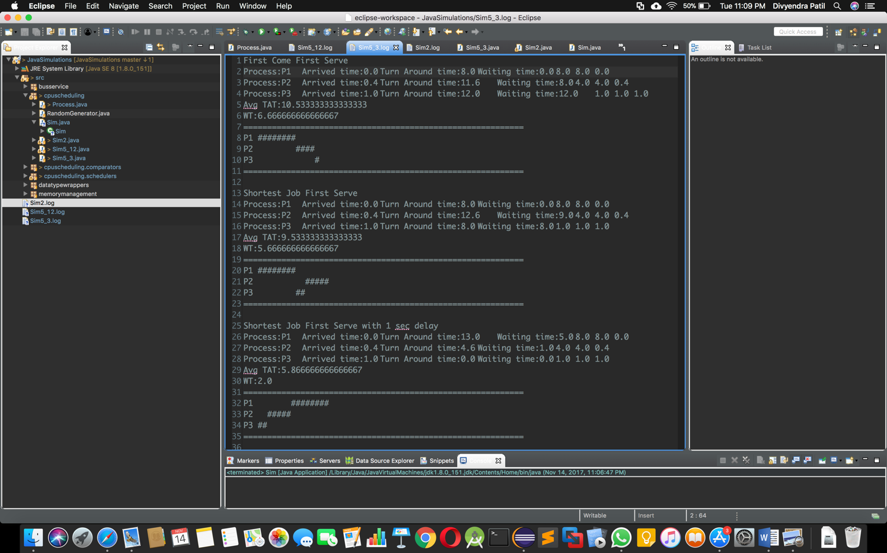

**Question 5.12:**

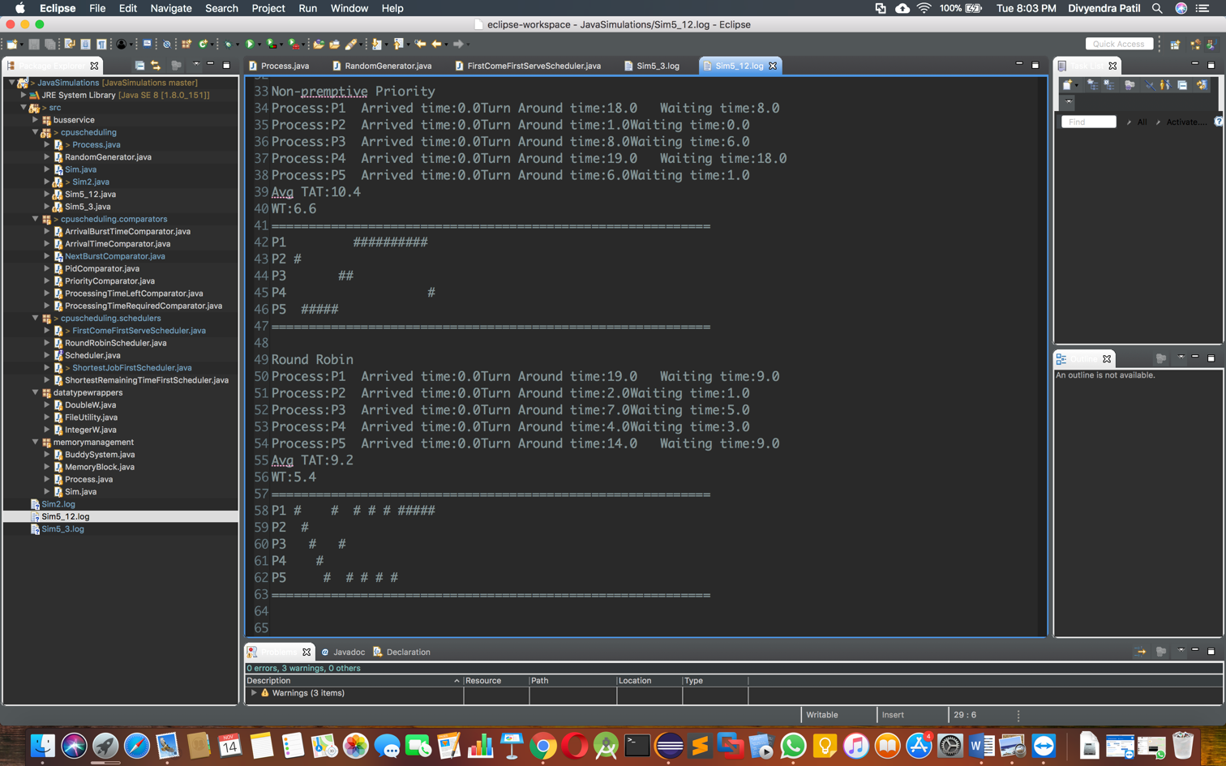

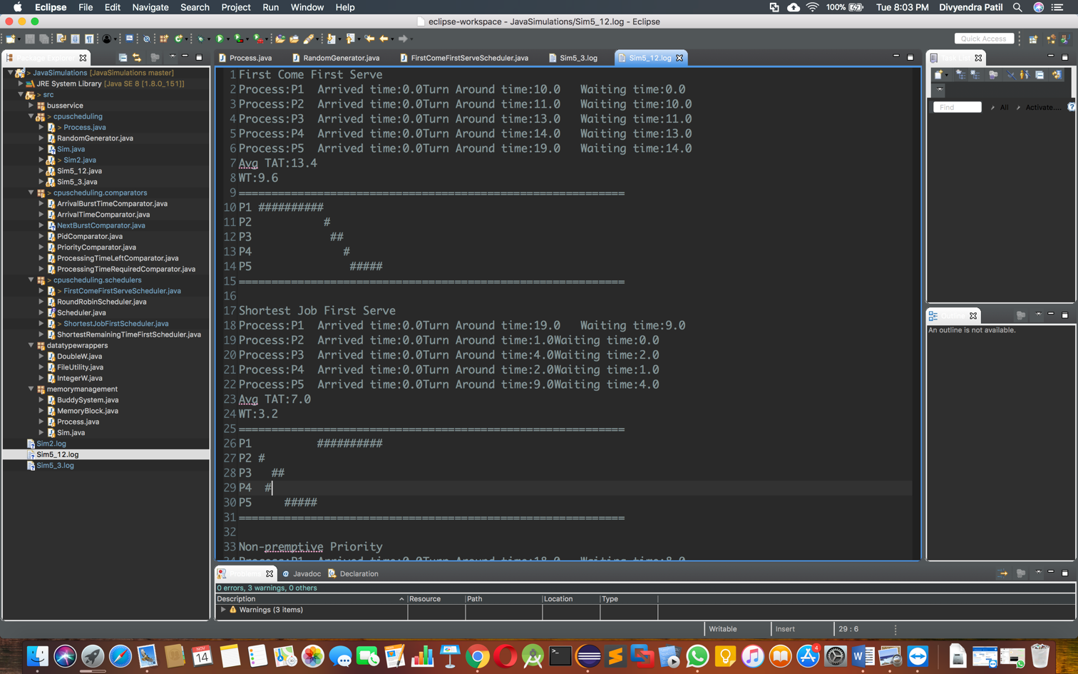

**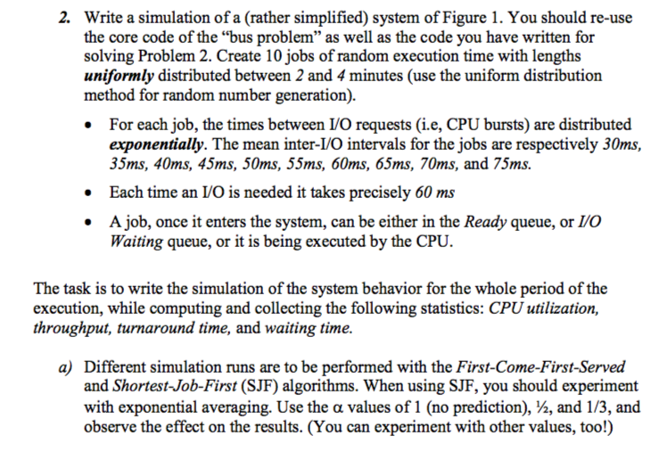  
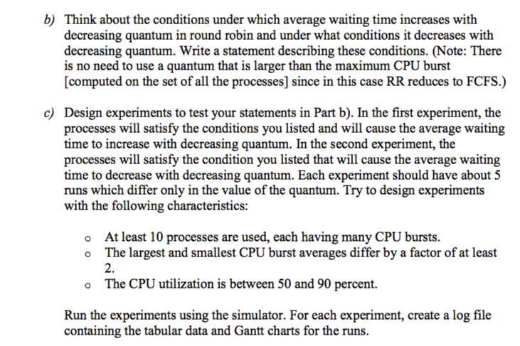**

**Solution:**

Mean CPU Bursts range 30ms-75ms with 5ms interval between two jobs. There are 10 Jobs.  
And there are IO burst of 60ms during which other process can use the CPU.

Explanation for simulation:

We know that First Come First Serve (FCFS) and SJF are non-preemptive algorithms but SJF can be preemptive.   
In the simulation both the algorithms are made non-preemptive. All the processes are given same priority for the simulation.

**Process selection in algorithm:**

In FCFS, the process execution in CPU happens as they arrive in Ready-Queue.   
For the SJF, the process is selected from ready queue with shortest CPU burst time.   
To predict the next CPU burst the formula which was taught in the lecture, is utilised.

Calculation parameters:

Turnaround time = Completion time – Arrival time  
Waiting time = Turnaround time – burst time  
CPU Utilization = (CPU Running time/ total simulation time) * 100  
Throughput = (Sum Processes/ total simulation time) * 100

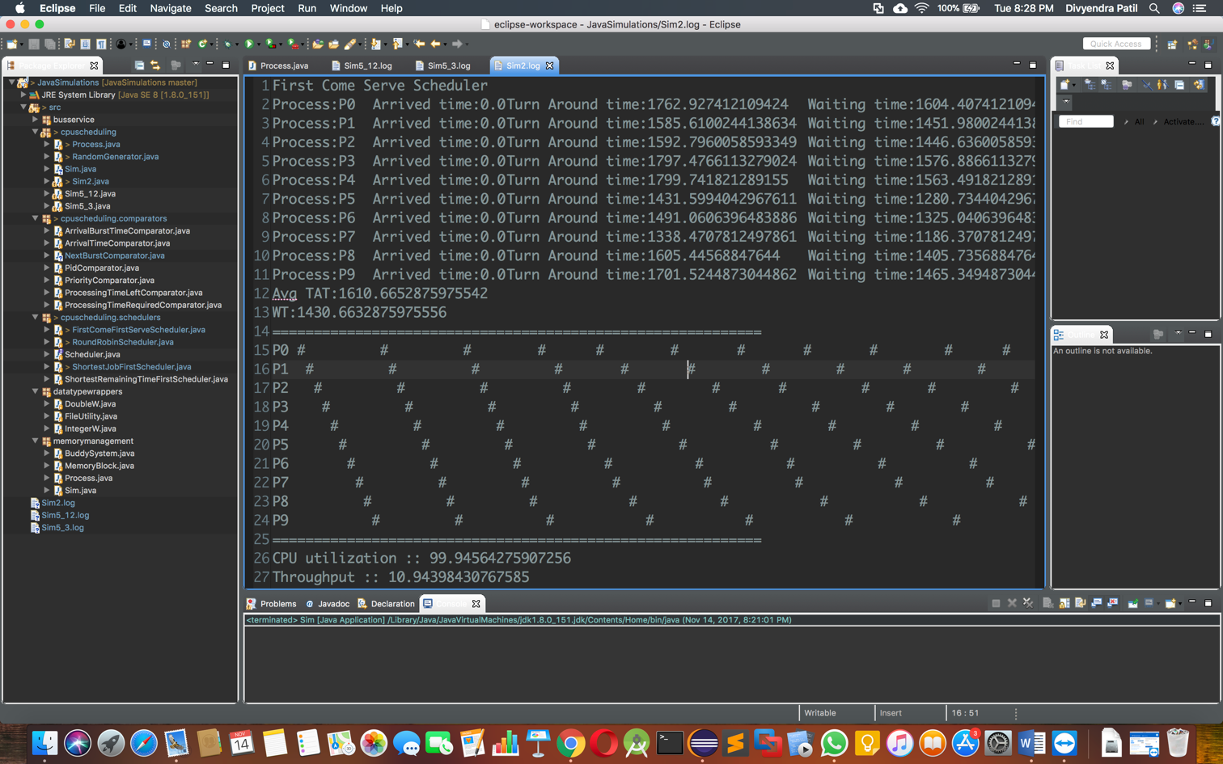

SJF: The ready queue is sorted after each arrival of process after IO and selected the first process with short burst time. Since the length of process arrival and burst time changes randomly, below is one instance of the execution taken randomly.

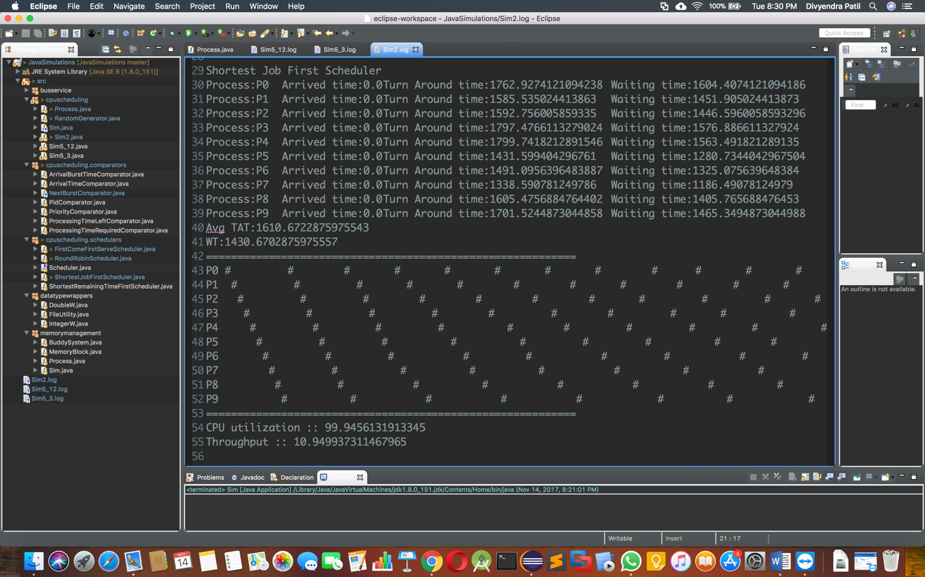

From the output we can clearly see that SJF increases Throughput and Utilization & Waiting time and Turnaround time are decreased compared to FCFS.

The change, either increase or decrease, in either parameters is substantial compared to FCFS.

Hence SJF is much better algorithm than FCFS in terms of output from CPU if IO processing time is same.

For SJF, to predict next burst using exponential averaging the formula used is:



α = 1 & ½

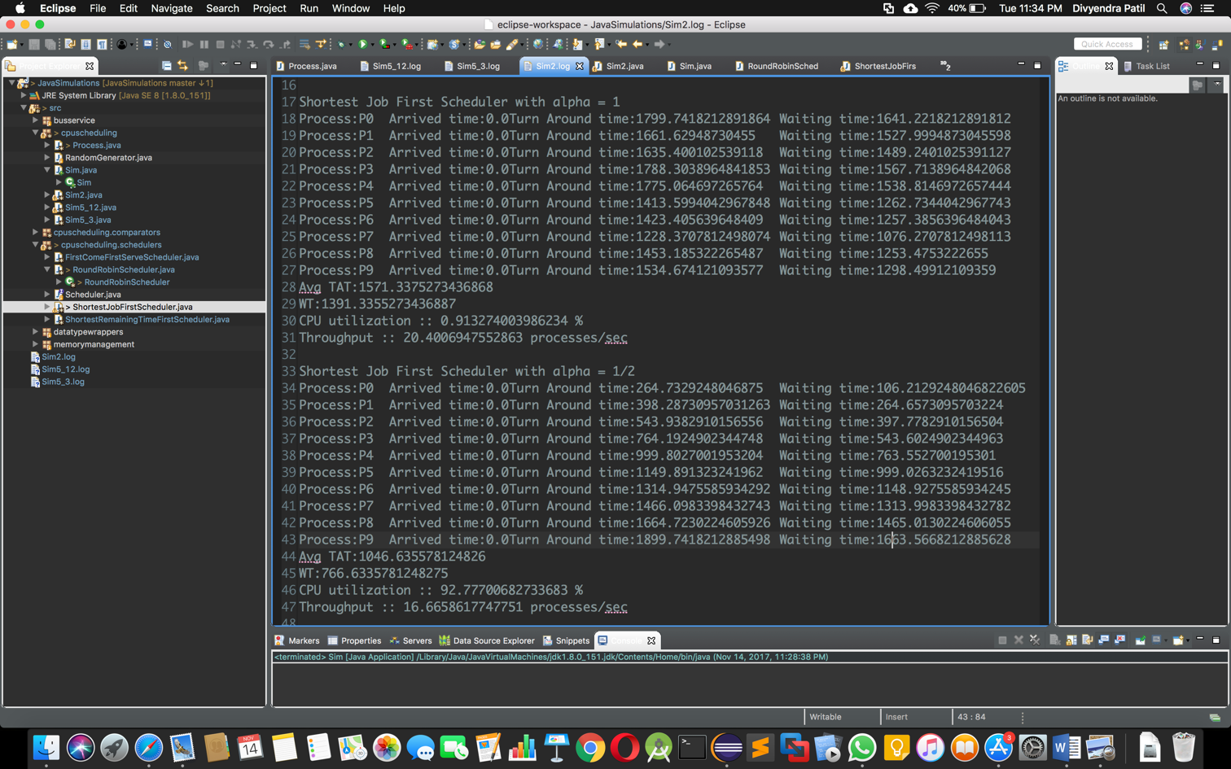

α = 1/3

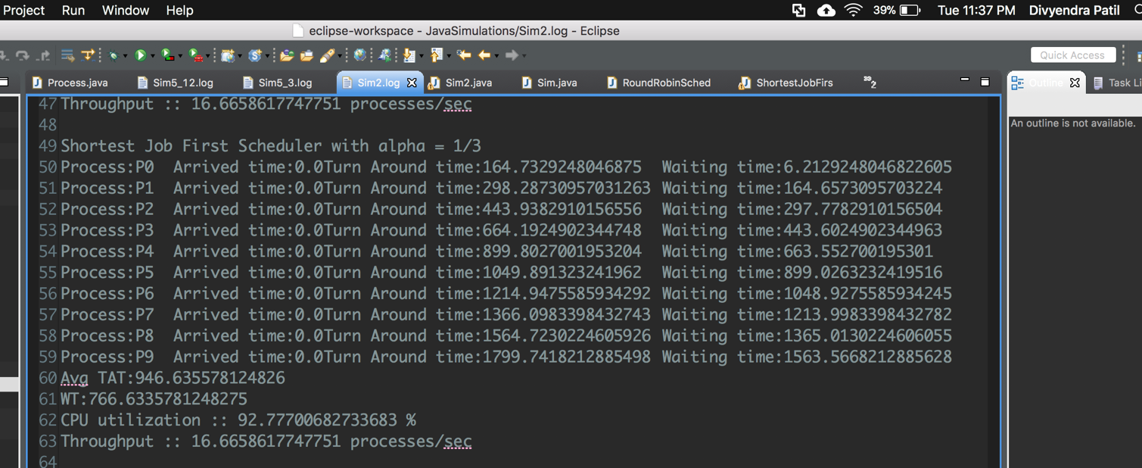

Initially the lengths of every job are the same as the first CPU burst time. And every time, new actual CPU burst time, random generate will return a number which based on the expect number n, and make a range as 10% of n, in the other word, the return value is between [0.9*n, 1.1*n], it is a such small change boundary. So change in *α* doesn’t affect much to efficiency parameters if its value is between 0.3 to 0.5. But beyond 0.75 the value of next burst changes unpredictably.   
At *α* = 1, the prediction becomes almost impossible when the simulation is run multiple times.

**Similarly for Round Robin:**  
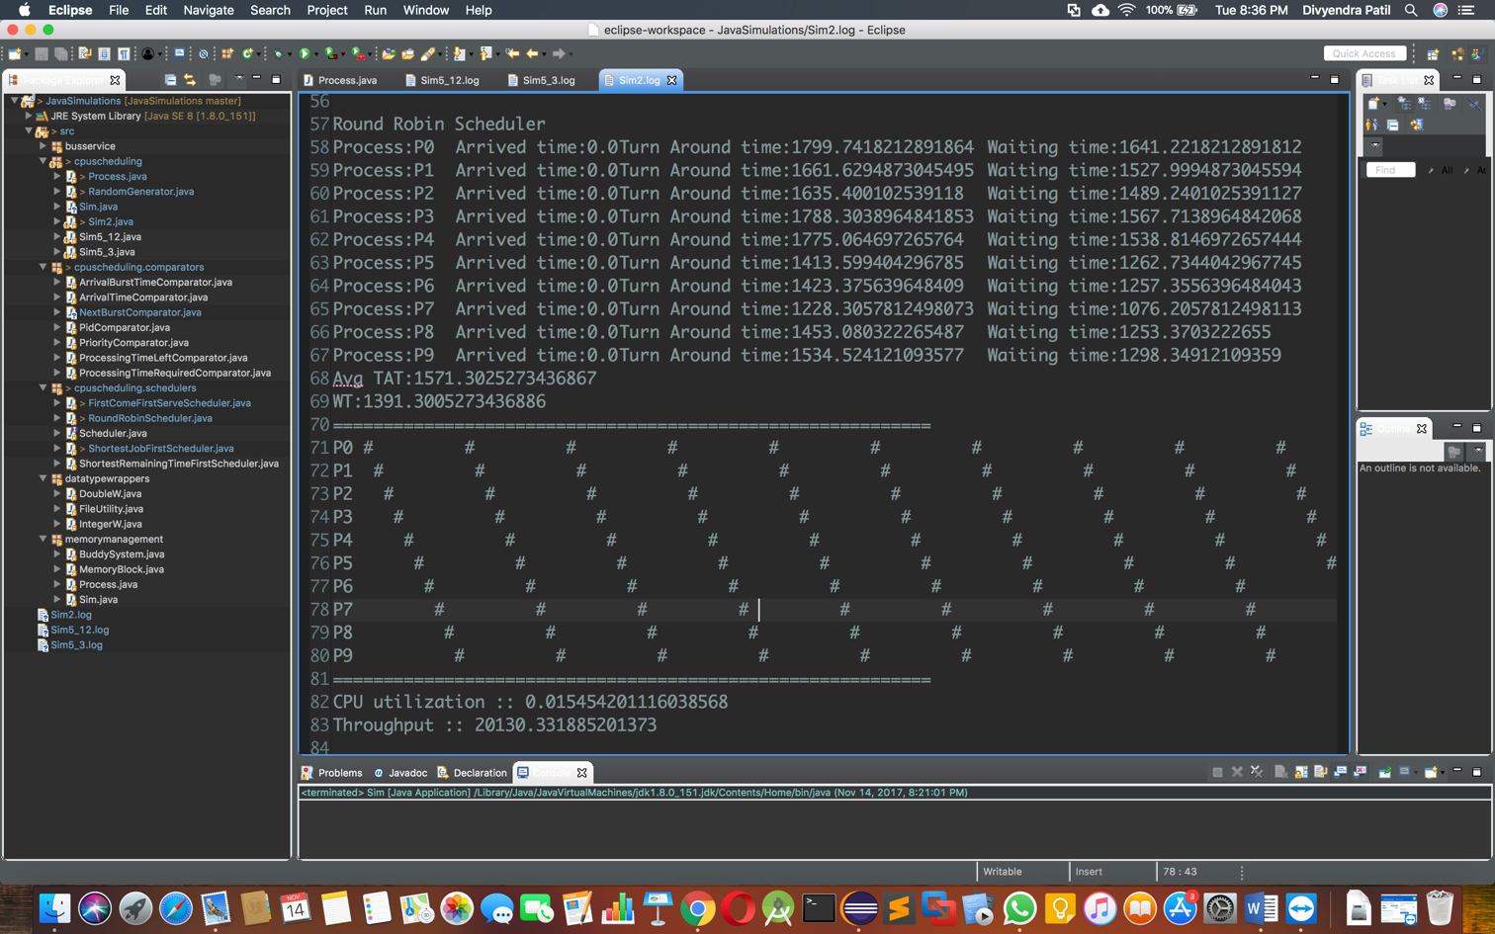

We know that Round Robin is preemptive scheduling. So, Equal CPU time slicing are assigned to each process in equal portion and are executed in circular order without considering priority.   
The CPU slicing assigned to each process is called as **Time Quantum** & the process is interrupted at the end of Quantum if the process isn’t completed by then & hence RR will not cause any **starvation** in the system.

The quantum selected affects the average waiting time. As the RR is preemptive algorithm, there is an overhead at the end of Quantum time in the form of Context Switch. If this Context Switch is constant the average waiting time will change with the value of Quantum time.

A] If the context switch cannot be neglected, then the average waiting will increase with decrease in the Quantum value.

B] However, if the context switch is neglected or made very small or made to increase with Quantum time compared to average length of the processes in the queue, the waiting time will decrease in the decrease in the Quantum value.

If the context switch time is reduced such that fast context switching is possible than the average waiting time will increase with respect to increase in Quantum hence to get maximum efficiency out of RR algorithm, Quantum has to be approximately equal to or in close range of average burst time of processes and the context switch time should be negligible.

C] There are 10 processes are used, and they are all execute for precisely 3 minutes, each CPU bursts are random generate among the range [30 ms,75ms].

The quantum value is changed & other variables may change with the change of quantum due to internal formulas.

For the first condition, the context switching time is constant and cannot be neglected & also the simulator is designed to have context switching time as 2ms.

In first condition, the context switching time is constant and cannot to be neglected.   
And also the simulator is designed to have context switching time as 2ms.

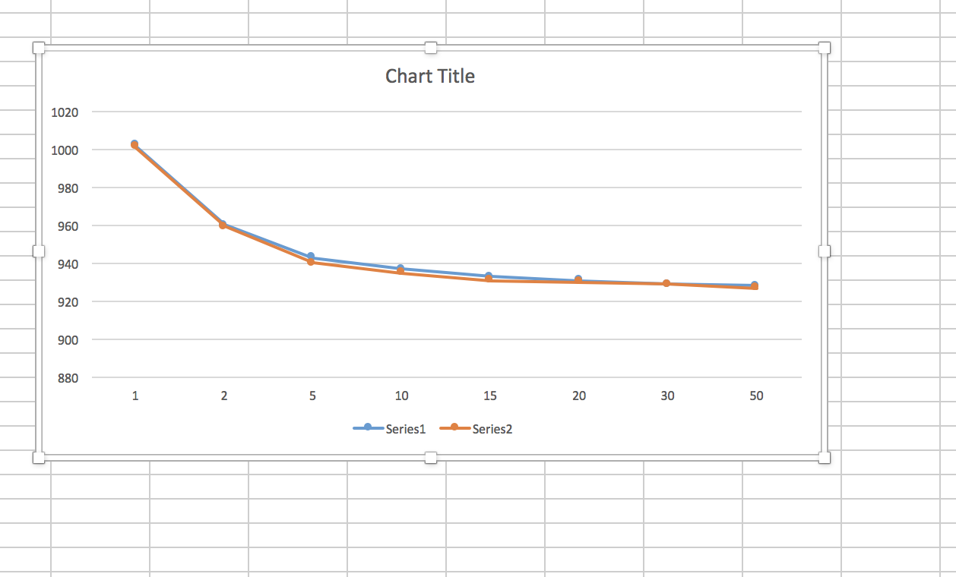

Above image shows that when we consider the context switching, the average waiting time decreases when Quantum is increased.

For the second condition, the context switching time is assumed to be increasing with Quantum at a constant rate.

The formula used is Context switch = (quantum * quantum)/200

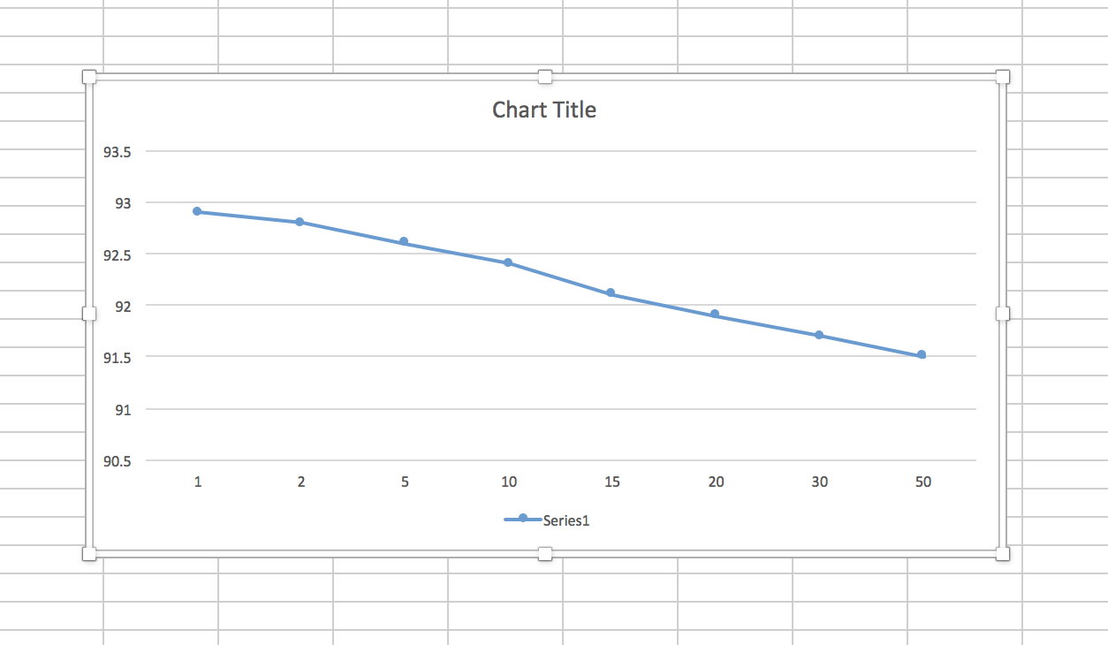

With increase in context switching, the CPU utilization decreases.

And in the absence of context switching the average waiting time increases with increase in Quantum. This is because now each process is utilizing the CPU more time and hence processes in the queue has to wait longer time to be executed on the CPU and thus increasing the waiting time.